***Exercise 1:***

The following data represent the growth of a population of fruit flies over a 6-week period. Test the following models by plotting an appropriate set of data. Estimate the parameters of the following model.

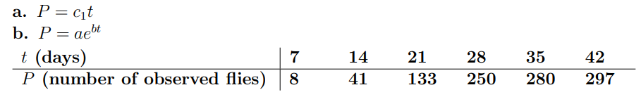

***Proof:***

1. 

Consider by substituting t into  we have such following:

* 
* 
* 
* 
* 
* 

Since point estimate: